Science Fair Design List

Design 1 – Initial
- When one or both hands is released, buzzer and indicator immediately activate
- Simple design, but doesn't account for non-phone usage-related activities in driving
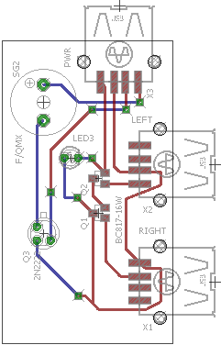
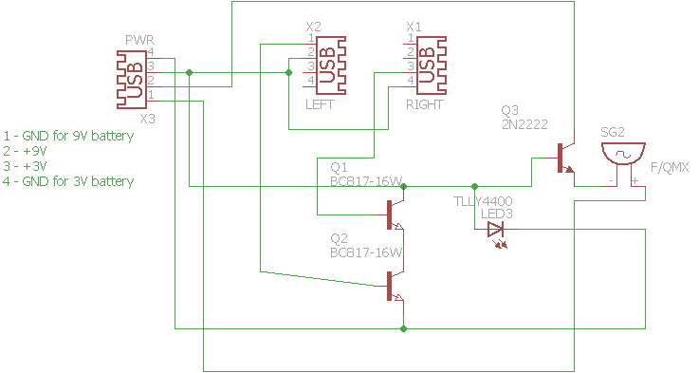
  - For example, radio or window controls
Design 2 – Unified Voltage
- BC817-16W transistors used for switching and amplification use up to 45V, but initial 3V may not be enough to detect hand position
  - Dual voltages (3V and 9V) were confusing
- 9V used instead
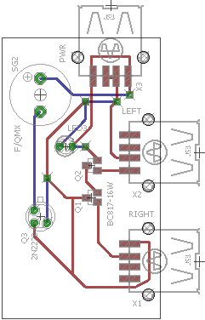
- Missing some resistors, so may cause issues with transistors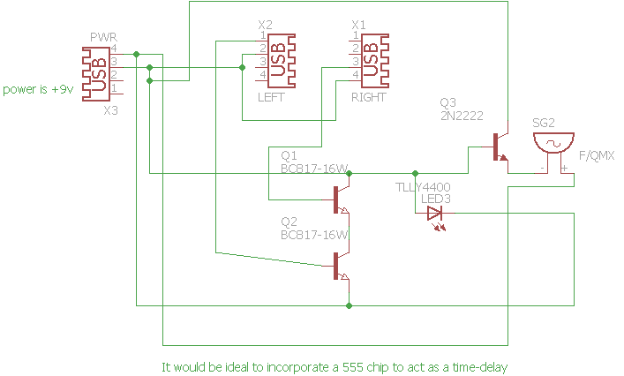
Design 3: 555 Chip Timer Delay
- Accounts for difficulty expressed in Design 1 of inability to move hands without activating alarms
- 555 IC plus accompanying circuitry adds a delay-before-on time of ~5 seconds
- May still cause issues with transistor voltage
  - If the contacts are short-circuited with a metal object, the semiconductor deiveces likely will blow up
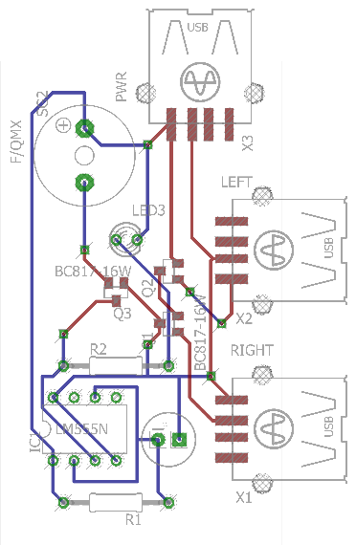
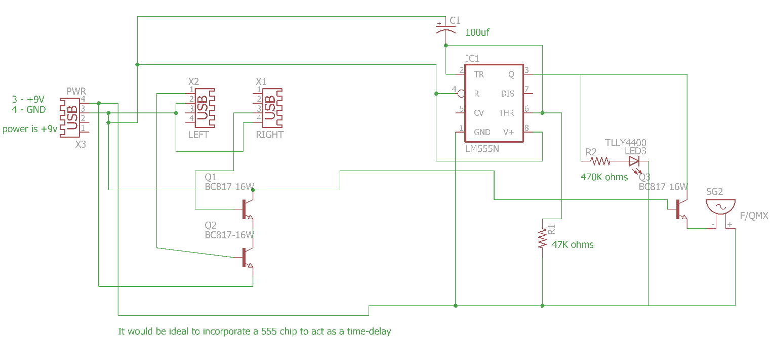
Design 4: Total Rework
- Solves difficulty with potential short-circuiting by users
  - Adds PTCs and Zener diodes to handle possible overvoltage
- Still powered by +9V, but chip and transistors work at +5V instead
  - Electrical hand contacts still at +9V to maximize likelihood of detecting continuity
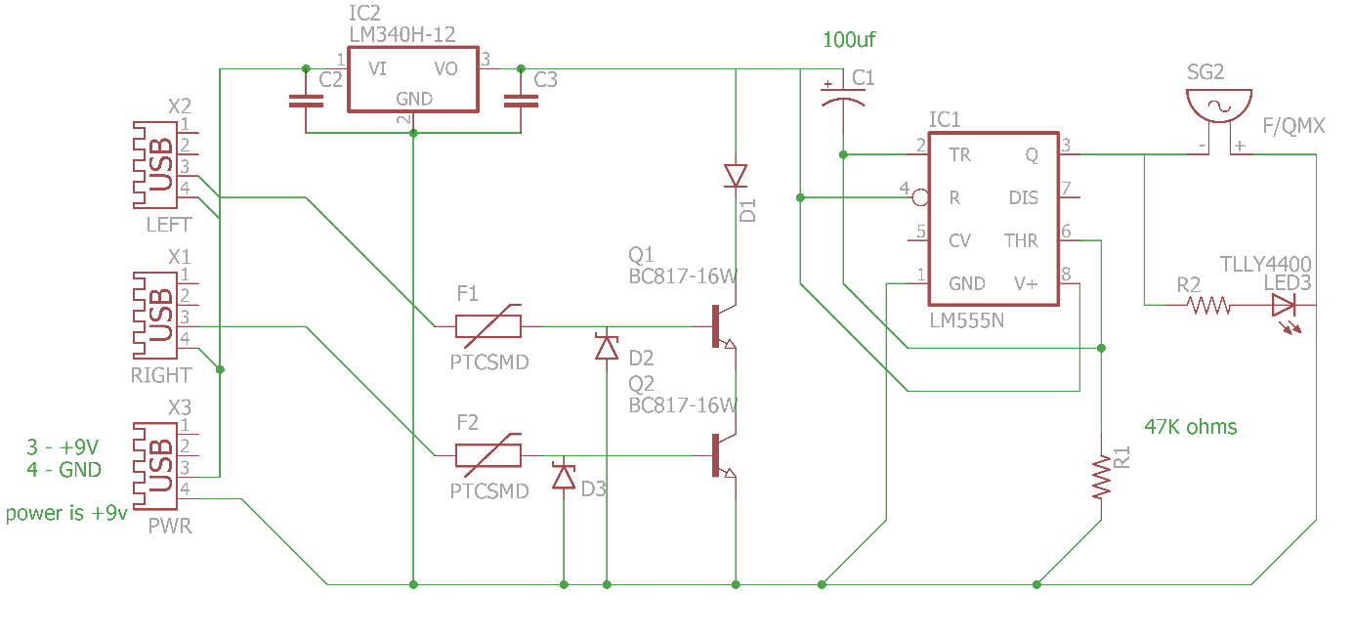
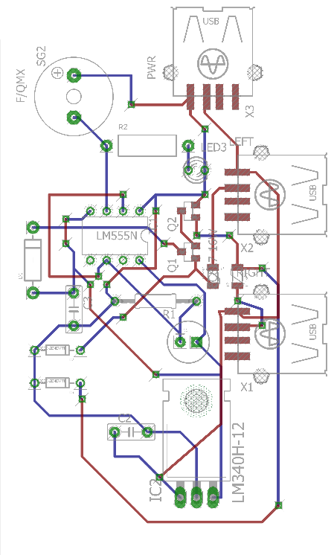
- Could potentially have issues with complex and messy trace layout
Design 5: Alternative USB
- As it turns out, Amazon is amazingly unhelpful for finding the USB connectors in previous design
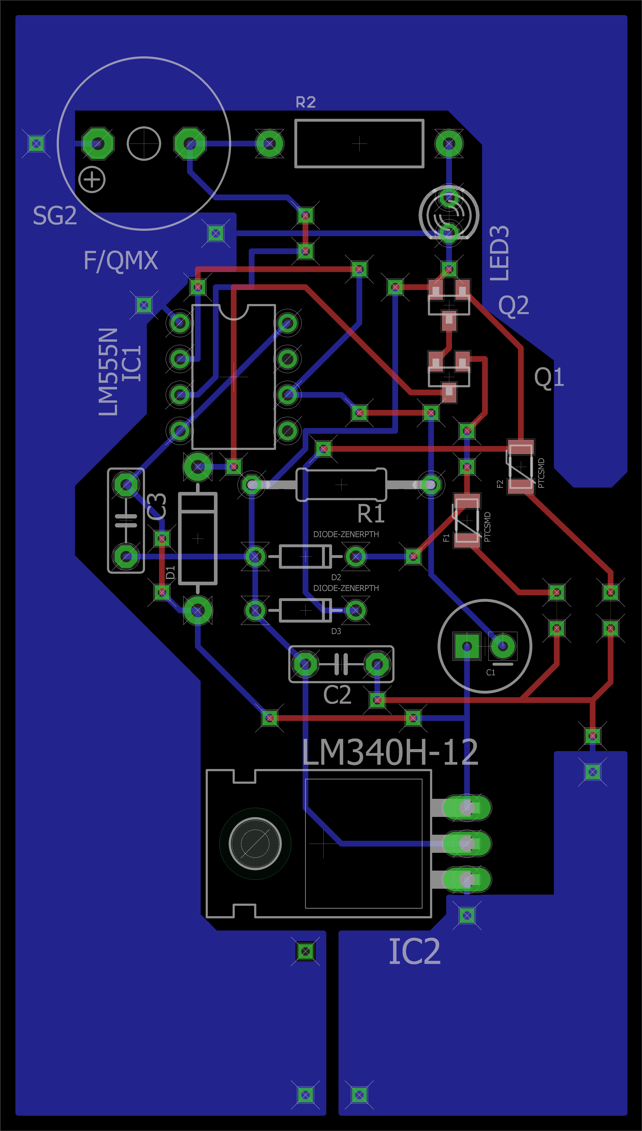
- Design altered to use copper pours for efficiency and Sparkfun USB breakout boards
Design 6: More pours
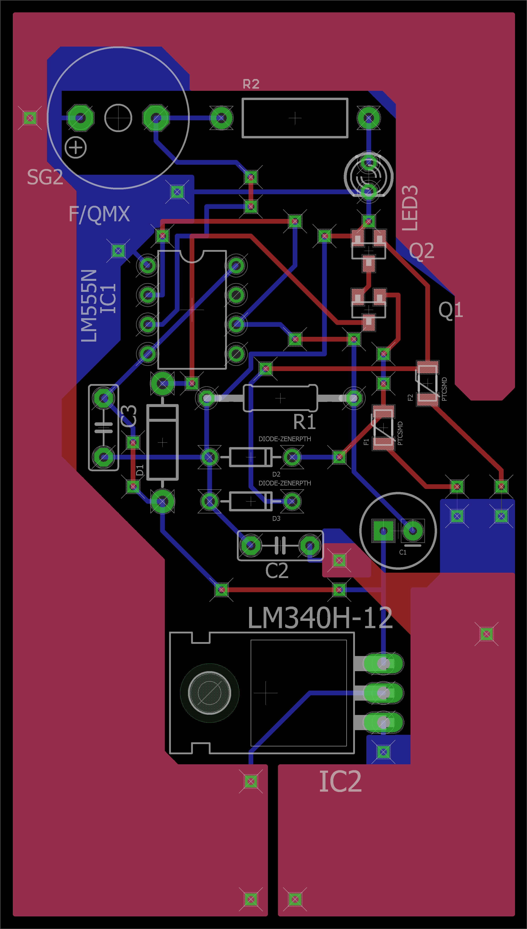
- More copper pours means less copper to etch
Design 7: Cost Reduction
- Unfortunately, some of the parts were too expensive to purchase on the given budget
- All surface mount devices removed, replaced with through-hole

